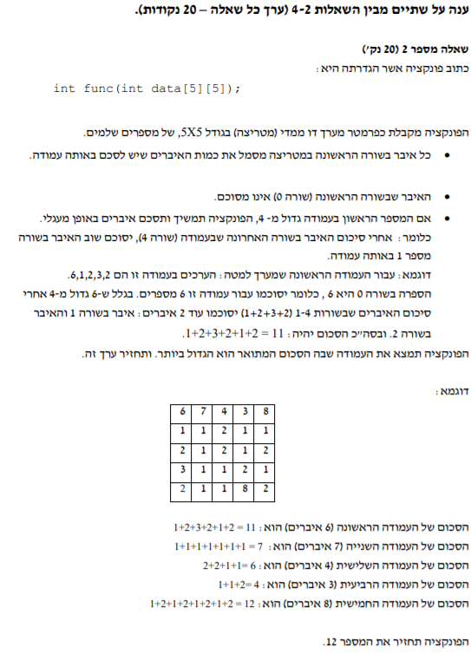

int func(int data[5][5])

{

int i, j = 0;

int counter, sum;

int bigsum = 0;

for (i = 0; i < 5; i++)

{

sum = 0;

counter = data[0][i];

for (j = 1; j <= counter; j++)

{

sum += data[j][i];

if (j == 4 && counter > 4)

{

j = 0;//return the row to row number 1(0 then +1 from the for line

counter -= 4;// decrease the number of times we will sum the cells in 4

}

}

if (sum > bigsum)//checks which sum is bigger

{

bigsum = sum;

}

printf("sum of col %d = %d\n", i, sum);

}

return bigsum;

}